Minor Participation Authorization and Consent to Emergency Medical Treatment Form - Sample

I, the undersigned, certify that I am the parent or legal guardian of (hereafter the “minor child”).
I hereby give my consent to have my minor child participate in the following activity of
<CHURCH NAME>: (hereafter “the activity”) on or about , 20 .
I recognize that there are risks involved in participating in this activity and hereby assume all risk of injury, harm, damage, or death to my minor child in connection with his/her participation in this activity.
To the fullest extent permitted by law, I release <CHURCH NAME>, its trustees, officers, directors, employees, agents and representatives from any injury, harm, damage or death which may occur to my minor child while participating in the activity and agree to save and hold harmless <CHURCH NAME>, its trustees, officers, directors, employees, agents and representatives from any claims arising out of my minor child’s participation in the activity.
Further, being the parent or legal guardian of the minor child, I do consent to any medical, surgical, x-ray, anesthetic, or dental treatment that may be deemed necessary for my minor child. I understand that efforts will be made to contact me prior to treatment but, in the event I cannot be reached in an emergency, I give permission to the activity leader to make the decisions necessary for treatment. Should there be no activity leader available, I give permission to the attending physician to treat my minor child. As parent or legal guardian, I understand that I am responsible for the health care decisions of my minor child and agree that my insurance plan is the primary plan to pay for the medical, dental, or hospital care or treatment that is given to my minor child. Any insurance policy of the church or organization sponsoring this event will be used as the secondary coverage.

Executed this day of , 20 .

Signature

Printed Name

Witness:

Witness:
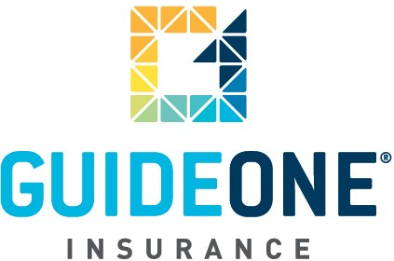
(07.01.08)
© 2010 GuideOne Center for Risk Management, LLC. All rights reserved.
This material is for information only and is not intended to provide legal or professional advice.
You are encouraged to consult with your own attorney or other expert consultants for a professional opinion specific to your situation.

