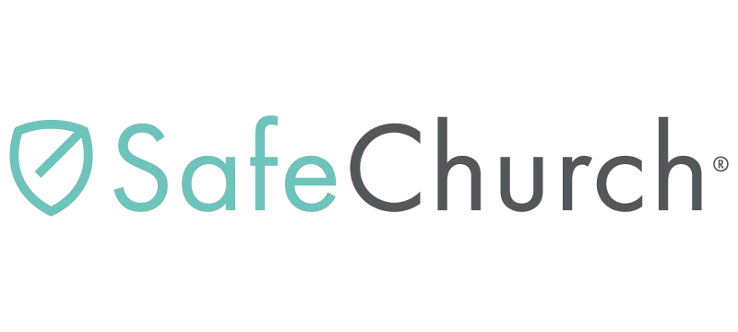
Disaster Relief Volunteer Agreement and Release - Sample
I, the undersigned volunteer of <CHURCH NAME> will be participating in disaster relief, recovery, and/or rebuilding efforts (hereafter the “relief effort”) in <LOCATION> on or about
to , 20 .
I understand that reasonable safety precautions will be taken by the leaders of the relief effort, but that the possibility of an unforeseen hazard does exist. I also acknowledge that there are some known hazards due to contamination following a natural disaster such as this. I hereby assume all risk of injury, harm, damage, or death in connection with my participation in the relief effort.
I understand and agree that neither <CHURCH NAME> nor its trustees, representatives, employees or agents may be held liable in any way for an occurrence(s) or incident(s) during the relief effort, which may result in injury, harm, damage or death. I hereby release <CHURCH NAME>, its trustees, employees, agents and representatives from any injury, harm, damage or death, which may occur while I am participating in the relief effort. To the fullest extent permitted by law, I agree to save and hold harmless <CHURCH NAME>, its trustees, employees, agents, or representatives from any claim by myself, my estate, heirs, successors, assigns, or other persons arising out of my participation in the relief effort.
I authorize <CHURCH NAME> through its trustees, employees, agents or representatives, to render or obtain such emergency medical care or treatment for me as may be necessary should any injury, harm, or accident occur to me while participating in the relief effort.
I further state that I am authorized to sign this document; that I understand the terms herein are contractual and not mere recitals; and that I have signed this document of my own free act and volition. I further acknowledge that I have fully informed myself concerning this release by reading it before I signed it.

Executed this day of , 20 .

Signature

Printed Name

Witness:

Witness:

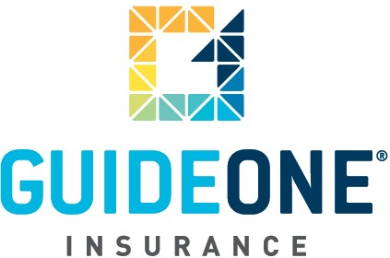

(09.01.06)

© 2010 GuideOne Center for Risk Management, LLC. All rights reserved.
This material is for information only and is not intended to provide legal or professional advice.

You are encouraged to consult with your own attorney or other expert consultants for a professional opinion specific to your situation.

