Mission Trip Participants - Release and Waiver of Liability Form for

Short Term Sample

I, the undersigned, will be participating in a short term mission trip to _ (hereafter the “mission trip”) on or about _ , 20_ _ to _ _, 20_ .
I recognize that there are risks involved in participating in the mission trip and hereby assume all risk of injury, harm, damage, or death in connection with my participation in it. I understand and agree that neither <CHURCH NAME> nor its trustees, officers, directors, employees, agents or representatives may be held liable in any way for any injury, harm, damage, or death that may occur to me as a result of my participation in this mission trip and hereby release <CHURCH NAME>, its trustees, officers, directors, employees, agents and representatives from any injury, harm, damage or death, which may occur while I am participating in the mission trip. To the fullest extent permitted by law, I agree to save and hold harmless <CHURCH NAME>, its trustees, officers, directors, employees, agents and representatives from any claim by myself, my estate, heirs, successors, assigns or other persons arising out of my participation in the mission trip.
I authorize <CHURCH NAME> through its trustees, officers, directors, employees, agents or representatives to render or obtain such emergency medical care or treatment for me as may be necessary should any injury, harm or accident occur to me while participating in the mission trip.

IF APPLICABLE:
{I understand and acknowledge that <CHURCH NAME> does not provide health or medical insurance in connection with the mission trip and I agree that I will be financially responsible for any bills incurred as a result of medical treatment, including emergency medical treatment and/or transportation to a medical facility, in connection with my participation in the mission trip.}
Executed this _ day of , 20__.

Signature _ _ _

Printed Name _

Witness: _ _

Witness: _ _
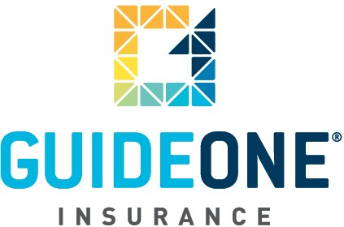

(07.01.08)

© 2010 GuideOne Center for Risk Management, LLC. All rights reserved.
This material is for information only and is not intended to provide legal or professional advice.

You are encouraged to consult with your own attorney or other expert consultants for a professional opinion specific to your situation .

